**LINGI 2315 - Homework 5 - My Nios App P1**

|  |  |  |  |
| --- | --- | --- | --- |
| Name | Delcoigne Ben | Noma | 38771700 |

Description of the software on Nios with relevant screenshots of your code

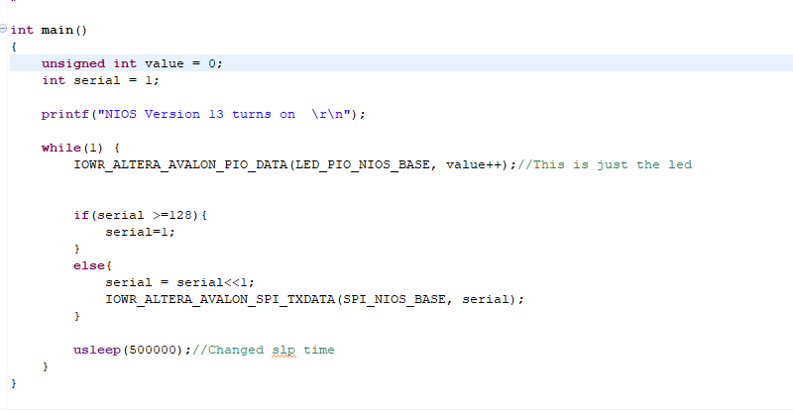

For the NIOS part I just created a LED mask (called serial) that I move to the right by one every time. Meanwhile the LED pio just increments itself each time.

The serial is then written in the SPI for the nios.

Do note that i had to **#include** "altera_avalon_spi_regs.h" in order for the code to work.

**LINGI 2315 - Homework 5 - My Nios App P2**

|  |  |  |  |  |
| --- | --- | --- | --- | --- |
| Name | Delcoigne Ben | 38771700 | Noma |  |

Description of the software on HPS with relevant screenshots of your code

The HPS part was the main part of this homework, I first modified the spi interrupt task in order to retrieve the value that was sent to it by NIOS:

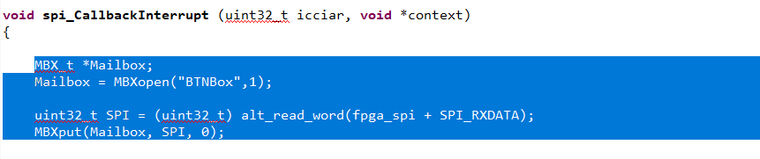

This is written in a mailbox (the value is just written into it)

Another thing I did was use the same mailbox to put the button values into:

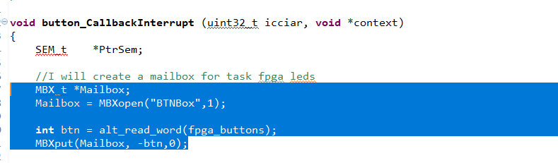Note: I put the negative value of the button

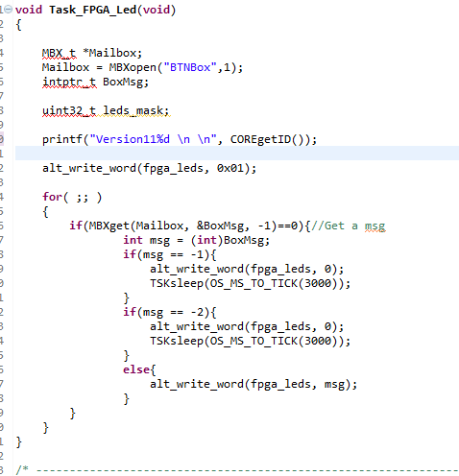

The last step was to modify the fgpa led task in order to read the mailbox. It either prints only zeros or ones depending on the button press (if it’s -1 or -2); otherwise it just writes the content of the mailbox.